Book Store Inventory Management

- Step 1: Read inventory file from json file
  - To read inventory we open inventory.json in read mode and load content into a variable name inventory.
  - Then we print Total number of Books
  - Please check below the code screenshot:
  - 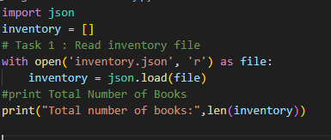

  - Import json allowed us to work with json file
  - Open with “r” is used to open file in read mode.
  - Josn.load(file) convert json data into python list
  - len(invetory) used to count entries

- Step 2: adding new book
  - Here we append new_book variable to inventory list and write it to inventory.json file
  - 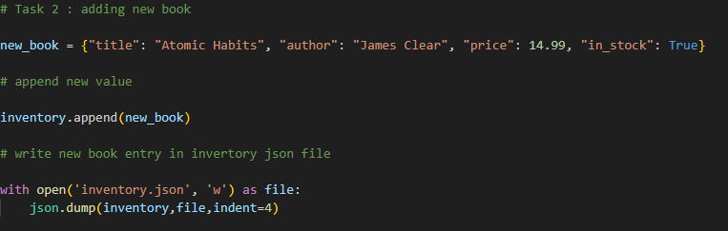

  - Inventory.append(new_book) add new entry to list
  - Open with “w” will allowed us to open file and write new record into json file
  - Json.dump(inventory,file,intent=4) writethe updated data

- Step 3:
  - Display all records with updated list
  - Print each book’s details in proper format
  - 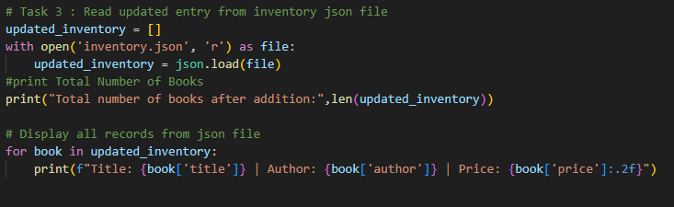

  - We reopen the file with open with “r”
  - In updated_inventory we load updated json data
  - Used for loop to display each record
  - :2f used to show the price value with 2 decimal pint

Output is look like:
